SUPPLEMENTAL MATERIAL:
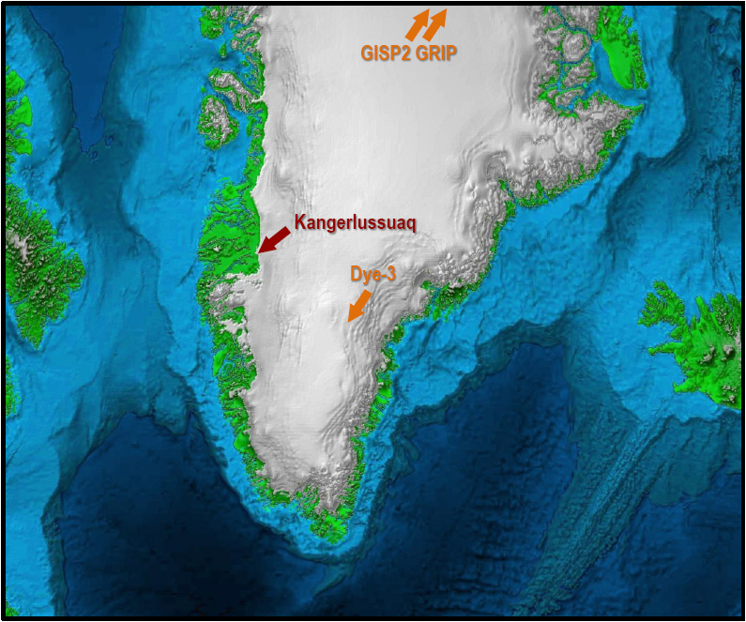

Fig. S1.
Greenland Sampling Site. Our sampling site is near Kangerlussuaq in central West Greenland ~160 km east of Davis Strait and Baffin Bay. The deep ice core drill sites of GISP2 and GRIP are ~750 km to the NE near the highest elevation of the ice sheet.

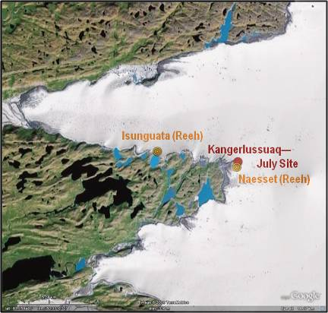

Fig. S2.
Location of Kangerlussuaq and other nearby sites at ice margin. Our sampling site (July, 08) is located just west of Kangerlussuaq between the previously sampled Isunguata and Naesset sites (Reeh et al.). The latter site is located on the ice sheet front ~330 meters SSW of our site. Isunguata is ~5.9 km to the west. Previous site locations are from Reeh, et al., Annals of Glaciology 35, 2002. [Google Earth]

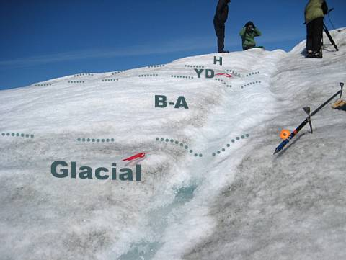

Fig. S3 During warmer periods, such as the Bølling-Ållerød (B-A) at 14.5 ka, the snow accumulated less dust and therefore the ice was lighter in color. In turn, the cold YD was grayer, and the Holocene, which followed it, is clearer again.
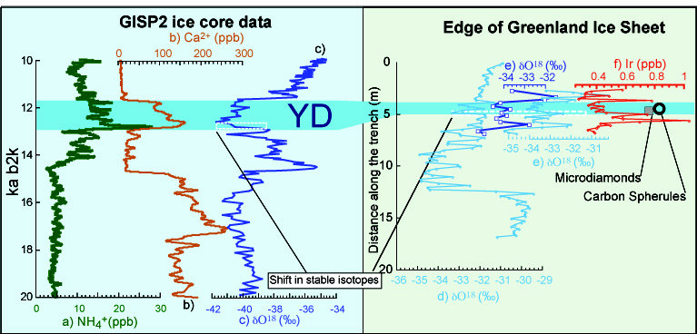
[THIS FIGURE SHOULD BE REVISED FOR THE NEW PAPER. PERHAPS DO ONLY GISPS??.
Fig. S4 Right panel displays δ¹⁸O values for the Kangerlussuaq site, along with abundances of CS and nanodiamonds, and the YD highlighted in blue. Left panel shows results from the GISP2 core: values for ammonium (biomass burning proxy), calcium (wind and dust proxy), and δ¹⁸O. (See Table S2 and S3 for data.)

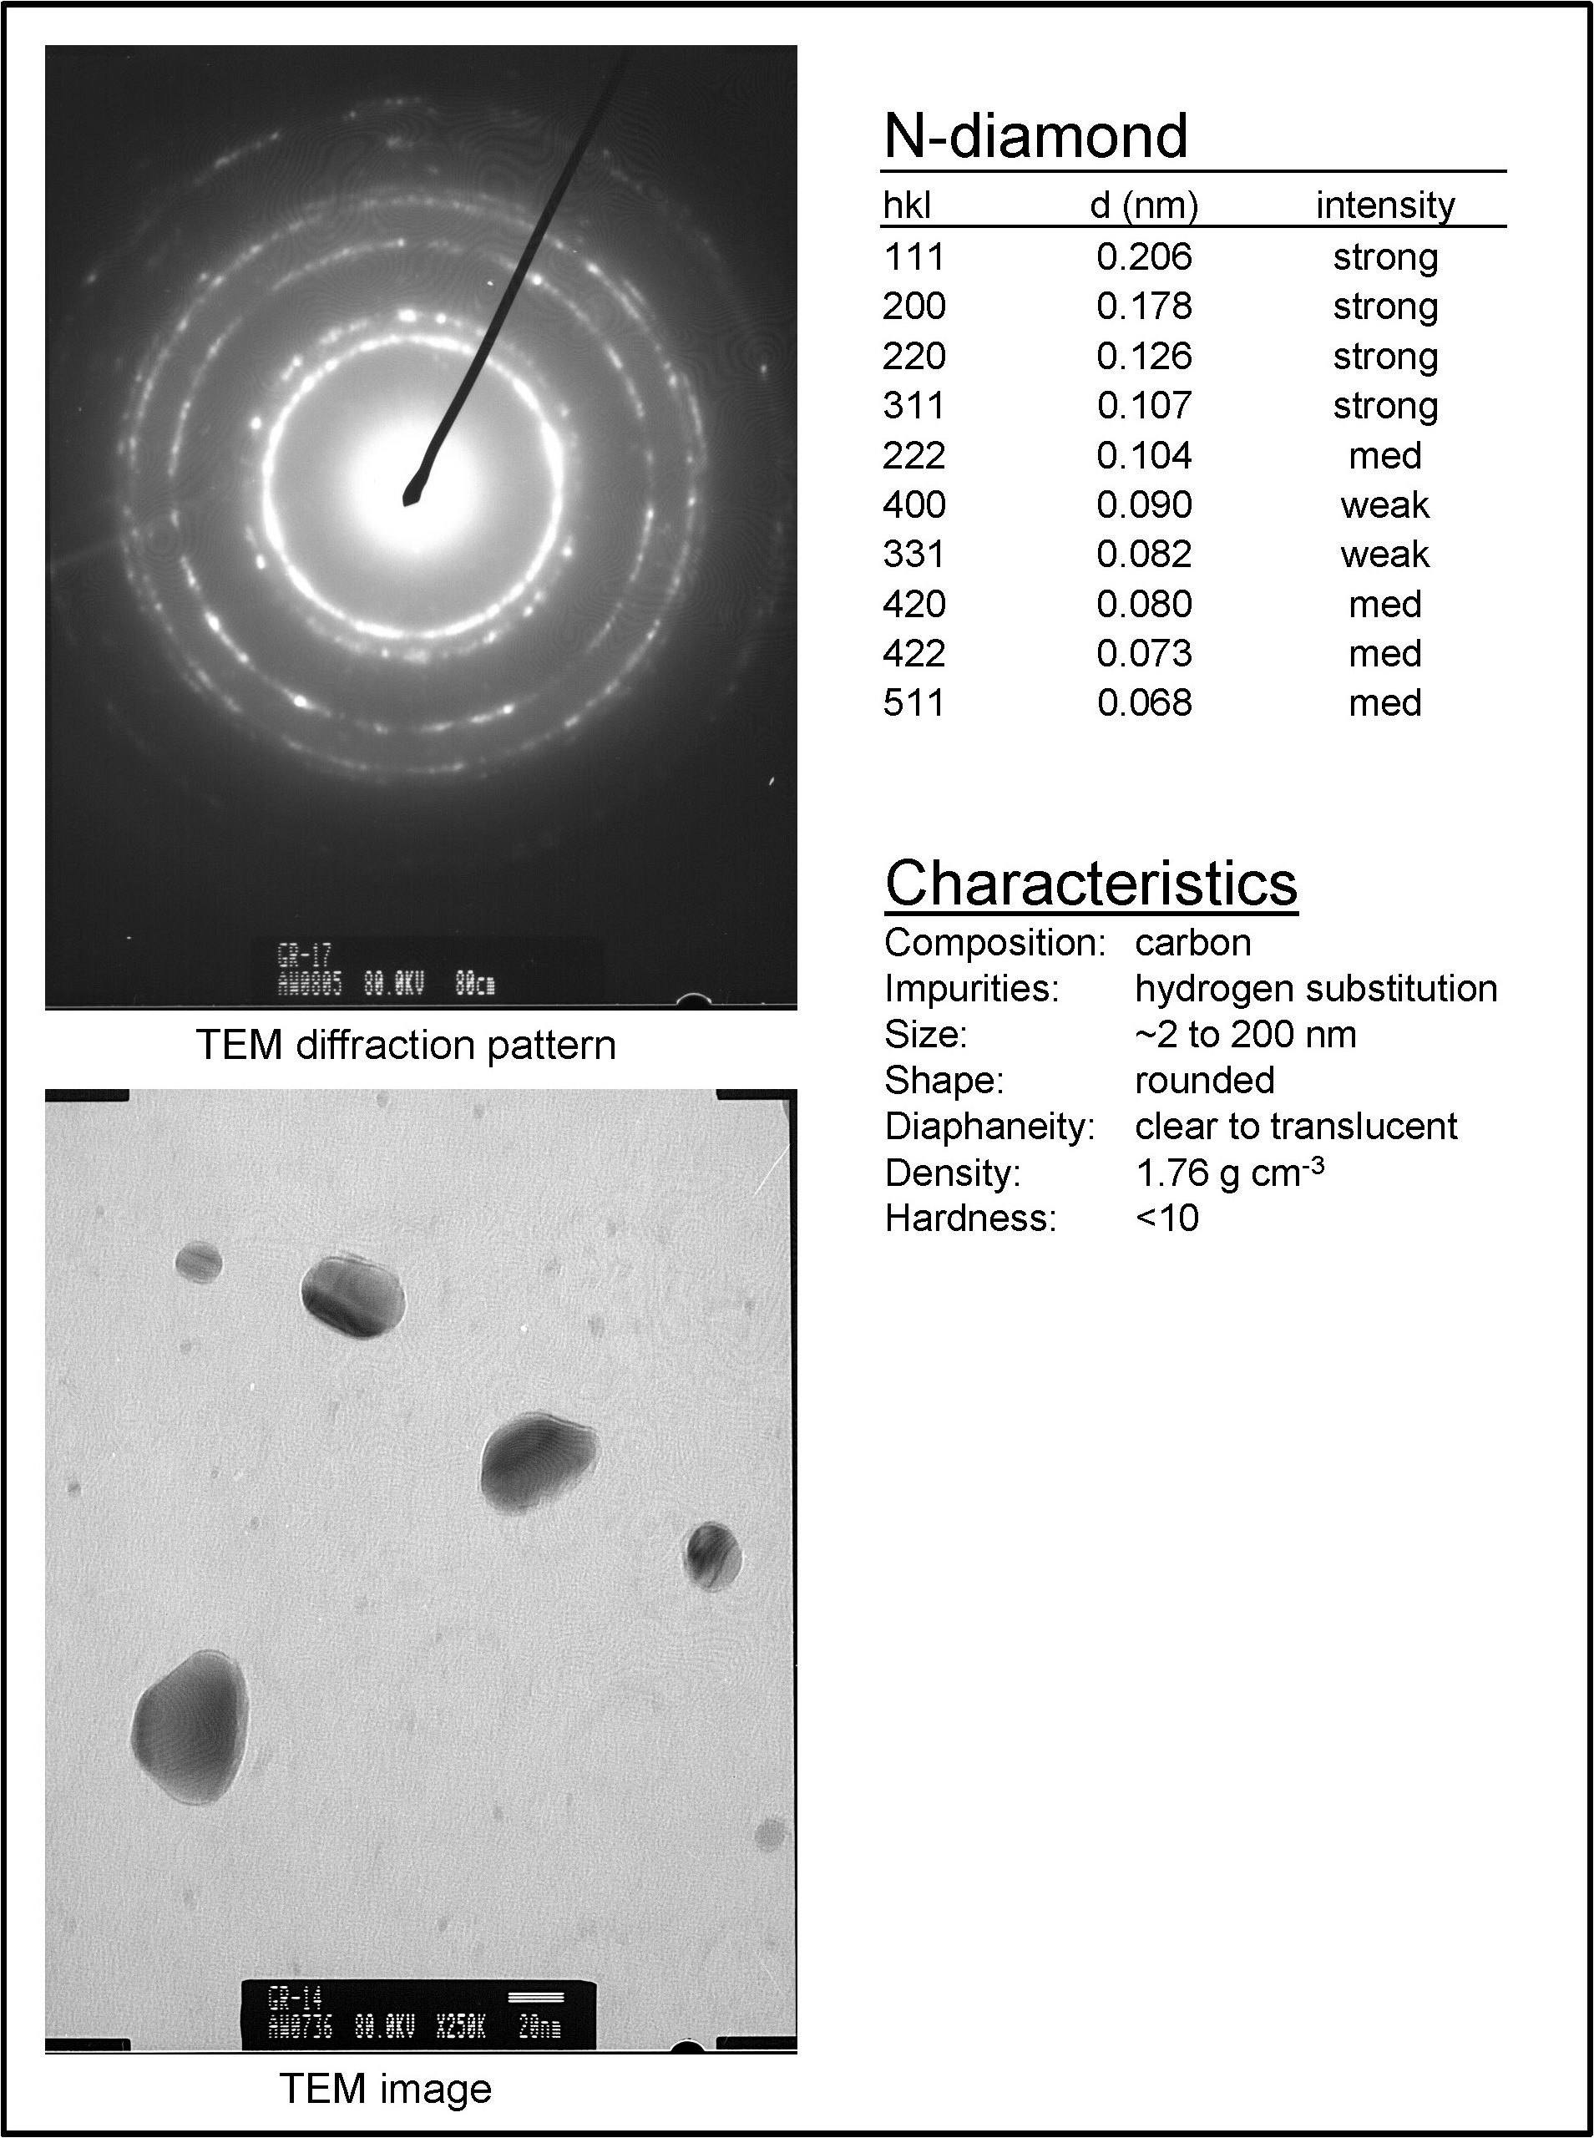
Fig. S5. N-diamond information.
--INCLUDE LABELS OF LINES?? --ADD HRTEM IMAGE (DOUG)?
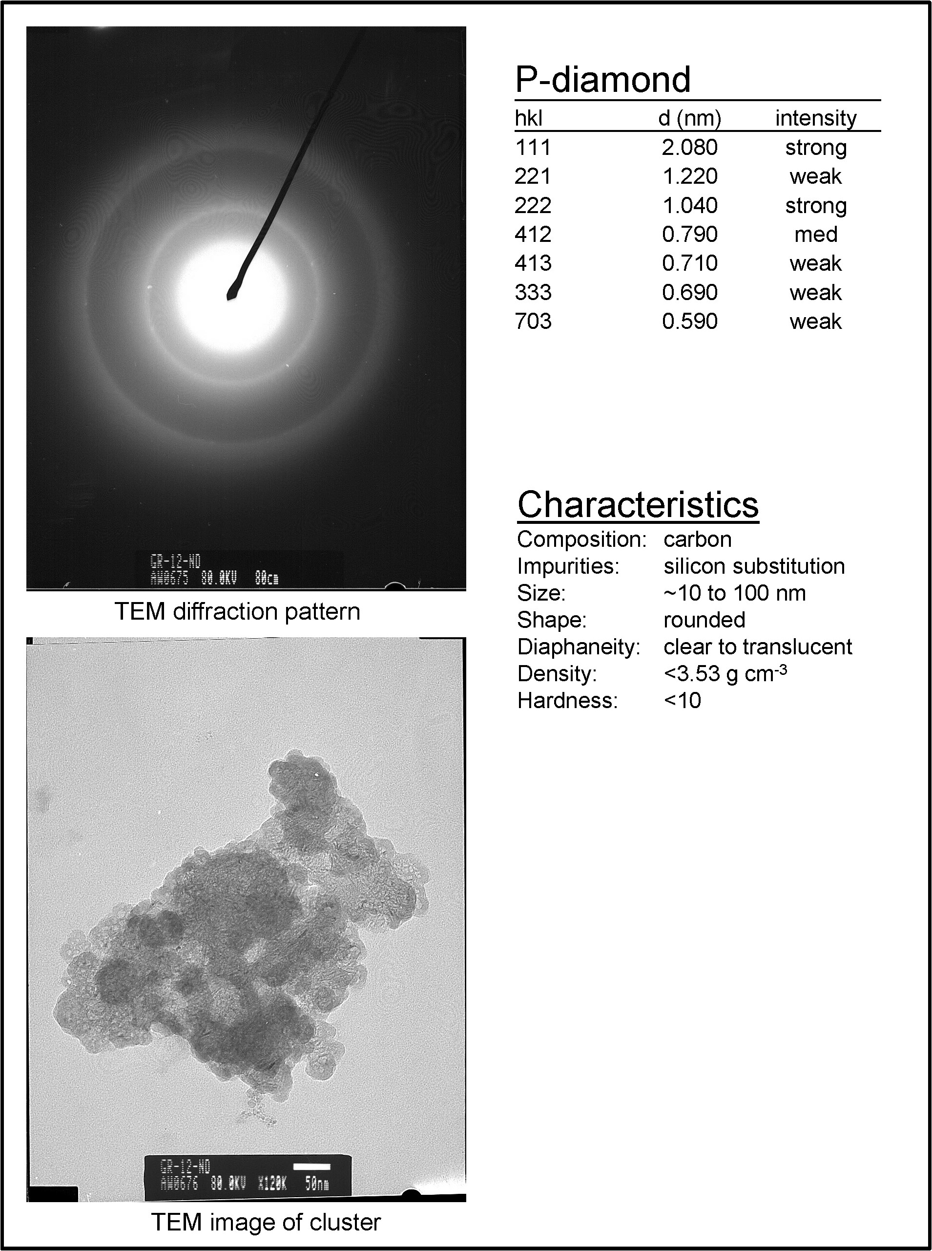
Fig. S6. P-diamond information. ADD HRTEM IMAGE (DOUG)?

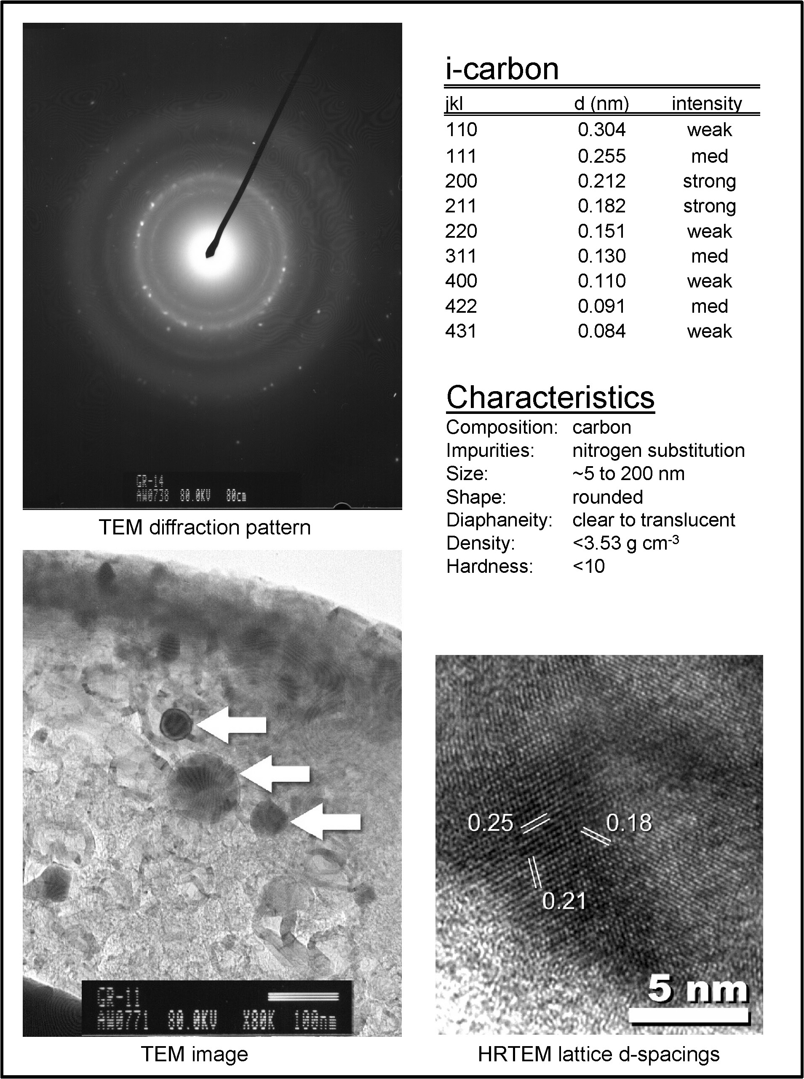
Fig. S7. I-carbon information. SMALLER ARROWS ON THE TEM IMAGE

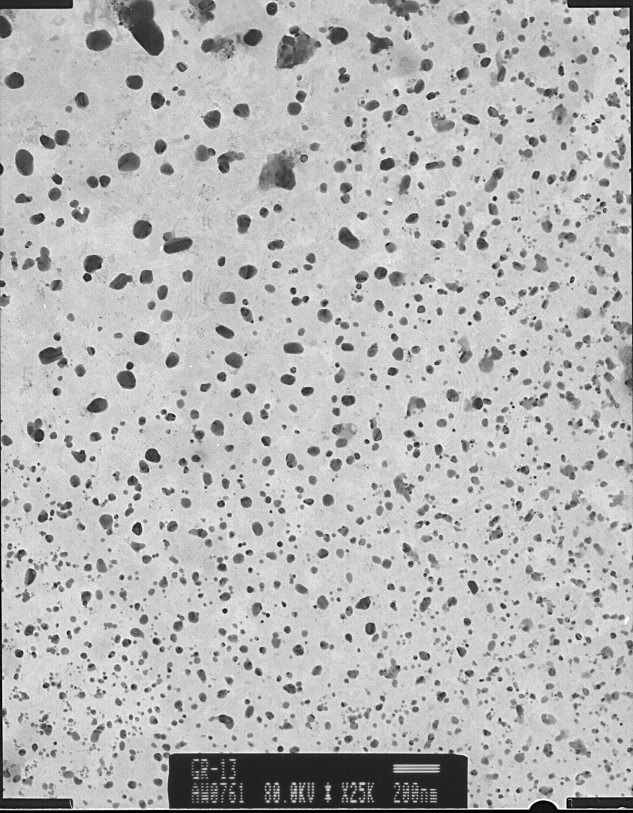
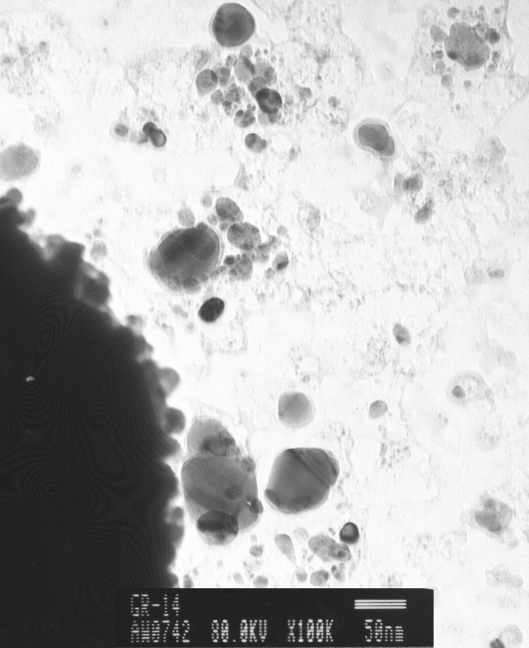

Fig. S8. TEM images. Left, field of several 1000 mixed diamonds. Right, group of i-carbon.

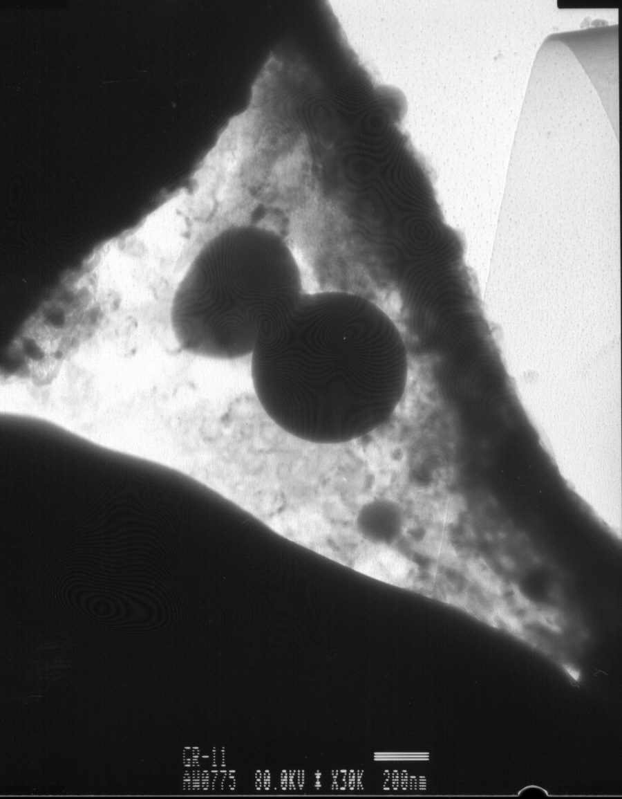
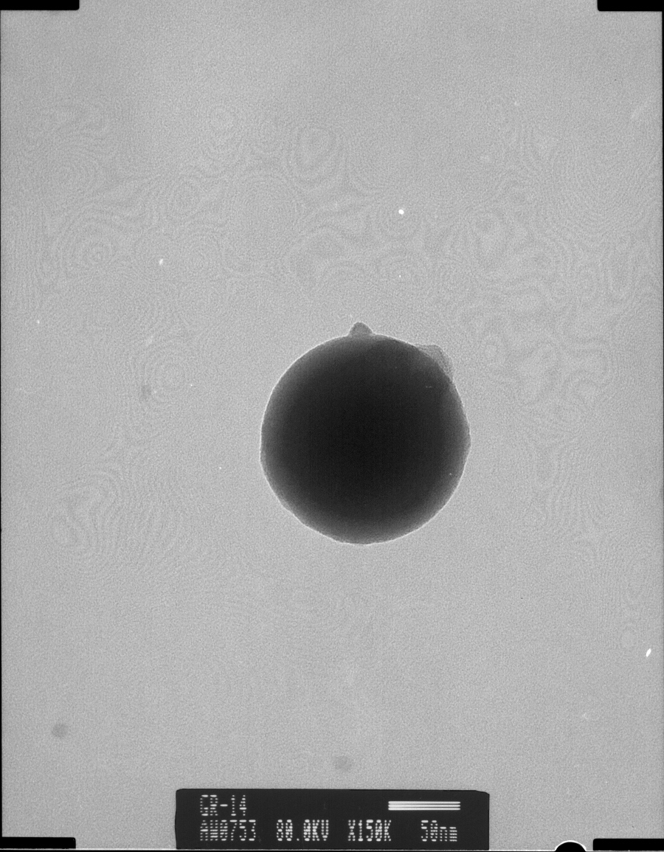

Fig. S9. TEM images of carbon spherules ranging from 150 nm (right) to 500 nm.

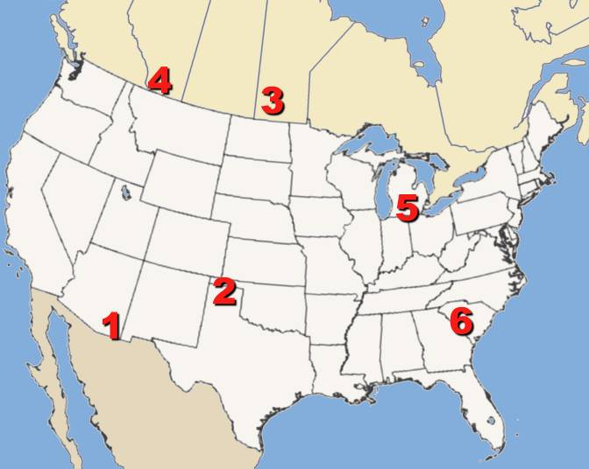
Fig. S10. Existing YDB diamond locations in North America: (1) Murray Springs, AZ: 200 ppb; (2) Bull Creek, OK: 100 ppb; (3) Lake Hind, MB, Canada: 70 ppb; (4) Chobot, AB, Canada: 10 ppb; (5) Gainey, MI: 3700 ppb; (6) Topper, SC: 108 ppb.

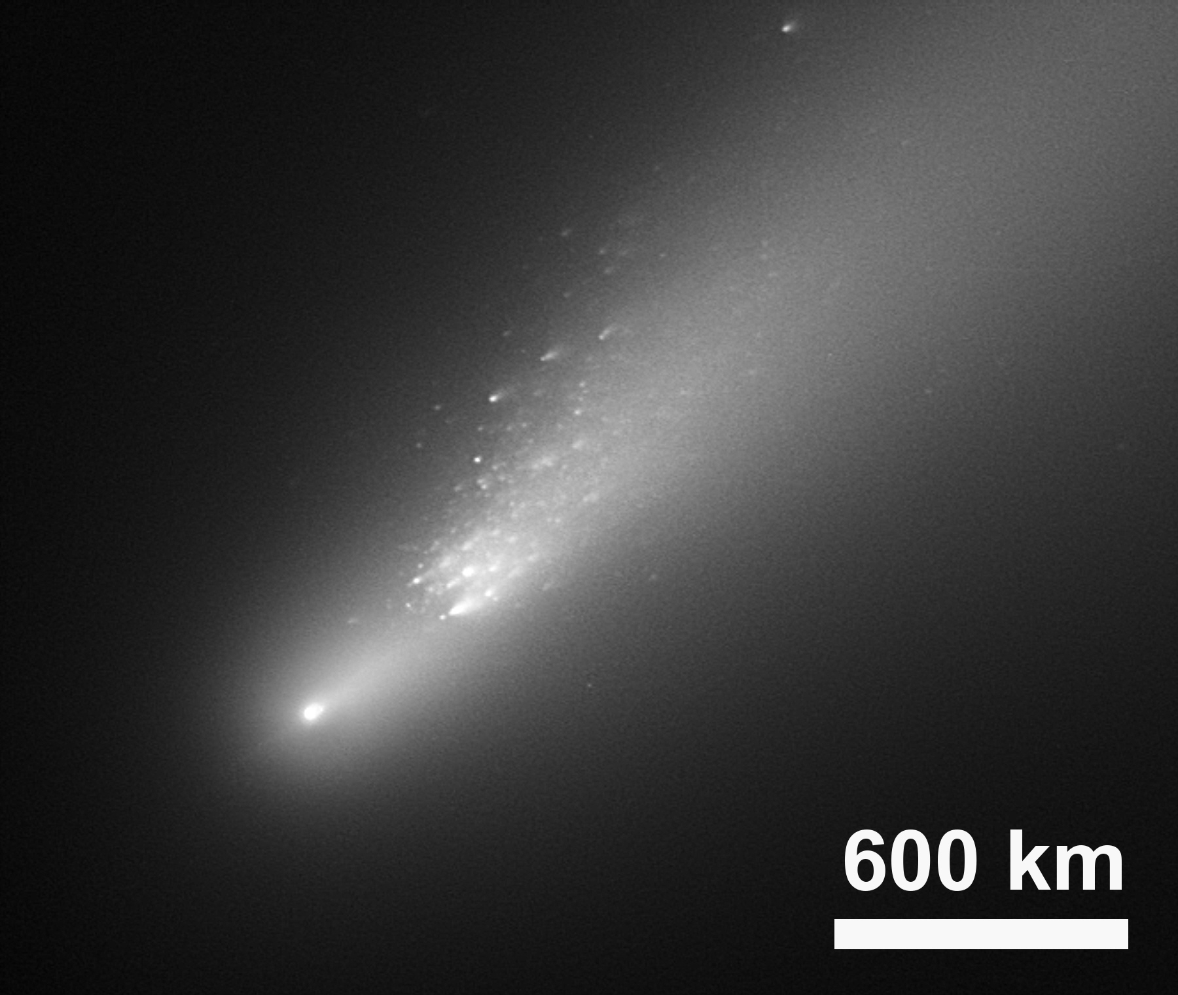
Fig. S11. For Comet Schwassmann-Wachmann 3B, all but one of the thousands of fragments were <125 meters in diameter (Nolan), and if they had hit Earth at typical velocity (51 km s⁻¹), density (1000 kg m⁻³), and angle (45°), those pieces would have exploded as airburst releasing thousands of megatons of energy (Collins). If the remaining 400-m fragment had impacted the 3-km-thick ice sheet or 3-km-deep portion of the oceans, it would have created a transient cavity in the ice sheet or ocean with limited effect on the subglacial surface or ocean bottom (Collins). In May, 2006, Schwassmann-Wachmann’s field of fragments was ≈4,000 km long and ≈1,500 km wide, half the width of North America, and the comet passed ≈25 times the distance to the Moon. If the entire Schwassmann-Wachmann shower had hit perpendicular to Earth’s orbit at 51 km s⁻¹, it would have done so catastrophically within just a few minutes.

Table S1: Sampling Site Information
Site | Location | Elev. (m) | Dis-tance (km) | YD (m) | δ¹⁸O Values |  |  | Ref
 |  |  |  |  | Glacial Episode | Younger Dryas | Holo-cene | Ref
GISP2 | 72.5883°N 38.4575°W | 3183 | 750 | 98 | -53.6 | -50.1 | -29.4 | Alley
Kangerlussuaq  (July site) | 67.1564°N 50.0233°W | 366 | 0 | 1 | -34.9 | -33.3 | -31.0 | This paper
Naesset | 67.1533°N 50.0250°W | 367 | 330 m | 50 | -33.0 | -31.9 | -28.0 | Reeh
Isunguata | 67.1617°N 50.1600°W | 313 | 5.9 | 12 | -33.9 | -31.0 | -28.0 | Reeh
Pakitsoq | 69.4317°N 50.2667°W | 350 | 250 | 1 | -39.6 | -39.0 | -32.5 | Reeh
Camp Century | 77.1660°N 61.1330°W | 1120 | 1170 | 9 | -42.0 | -39.0 | -29.0 | Dansgaard
Dye-3 | 65.1833°N 43.8167°W | 2470 | 350 | 4 | -35.6 | -35.1 | -27.0 | Dansgaard
MEAN |  |  |  | 12.8 | -36.5 | -34.9 | -29.3

Site locations, plus d18O. For the glacial period, the B-A, the YD, and the Holocene, the d18O values are a close match among the six sites away from central Greenland. They are all lower than at GISP2.
Table S2. δ¹⁸O values. COMBINE WITH ABOVE TABLE??

 | # | Top (m) | δ¹⁸O
 | 10 | 1.8 | -31.6
 | 11 | 2.0 | -31.6
 | 12 | 2.2 | -31.8
 | 13 | 2.4 | -32.0
 | 14 | 2.6 | -31.9
 | 15 | 2.8 | -31.9
 | 16 | 3.0 | -32.0
 | 17 | 3.2 | -31.9
 | 18 | 3.4 | -32.2
 | 19 | 3.6 | -32.2
 | 20 | 3.8 | -31.3
 | 21 | 4.0 | -33.0
 | 22 | 4.2 | -32.5
 | 23 | 4.4 | -31.8
 | 24 | 4.6 | -32.8
 | 25 | 4.8 | -33.3
 | 26 | 5.0 | -31.8
 | 27 | 5.2 | -31.7
 | 28 | 5.4 | -32.1
 | 29 | 5.6 | -31.9
 | 30 | 5.8 | -31.9
 | 31 | 6.0 | -32.5
 | 32 | 6.2 | -31.9
 | 33 | 6.4 | -32.8
 | 34 | 6.6 | -33.8
 | 35 | 6.8 | -33.0
 | 36 | 7.0 | -32.9
 | 37 | 7.2 | -31.8
 | 38 | 7.4 | -32.1
Shows δ¹⁸O values, as displayed in Figs. 2 and 3.
Table S3. Markers
 | # | Top (m) | N-diamonds  +Cubics |  | # | Top (m) | Carbon Spherules | # | Top (m) | Magnetic Grains | # | Top (m) | Dust from Ice
 |  |  | (billions) | (low ppt) |  |  | (#per Kg) |  |  | (g/kg) |  |  | (g/kg)
 |  |  |  |  | 29 (114) | 3.15 | 0 |  |  |  | 29 | 3.15 | 2.416
 |  |  |  |  |  |  |  |  |  |  | 28 | 3.30 | 1.897
 |  |  |  |  |  |  |  |  |  |  | 27 | 3.45 | 1.245
 | 26 | 3.60 | 0.000007 | 0.0125 |  |  |  | 26 | 3.60 | 0.0289 | 26 | 3.60 | 1.635
 |  |  |  |  | 25 (110) | 3.75 | 0 |  |  |  | 25 | 3.75 | 2.312
 | 24 | 3.90 | 0.000000 | 0.0000 |  |  |  |  |  |  | 24 | 3.90 | 2.811
 |  |  |  |  |  |  |  |  |  |  | 23 | 4.05 | 0.600
 | 22 | 4.20 | 0.000000 | 0.0000 |  |  |  | 22 | 4.20 | 0.0121 | 22 | 4.20 | 0.474
 |  |  |  |  |  |  |  |  |  |  | 21 | 4.35 | 0.472
 |  |  |  |  | 20 (105) | 4.50 | 0 |  |  |  | 20 | 4.50 | 0.454
 | 19 | 4.65 | 0.000000 | 0.0000 |  |  |  |  |  |  | 19 | 4.65 | 1.080
 |  |  |  |  |  |  |  |  |  |  | 18 | 4.80 | 1.152
 | 17 | 4.95 | 0.004975 | 0.0360 | 17 (102) | 4.95 | 0 | 17 | 4.95 | 0.0787 | 17 | 4.95 | 1.741
 | 16 | 5.10 | 0.000005 | 0.0980 |  |  |  | 16 | 5.10 | 0.0288 | 16 | 5.10 | 1.637
 | 15 | 5.25 | 0.000001 | 0.0010 | 15 (100) | 5.25 | 100 | 15 | 5.25 | 0.0287 | 15 | 5.25 | 1.575
 | 14 | 5.40 | 1.414730 | 5214.4436 | 14 (99) | 5.40 | 560 | 14 | 5.40 | 0.2489 | 14 | 5.40 | 1.052
 | 13 | 5.55 | 0.056983 | 105.0236 | 13 (98) | 5.55 | 640 | 13 | 5.55 | 0.5725 | 13 | 5.55 | 1.319
 | 12 | 5.70 | 0.000000 | 0.0002 | 12 (97) | 5.70 | 360 | 12 | 5.70 | 0.0223 | 12 | 5.70 | 1.231
 | 11 | 5.85 | 0.000001 | 0.0013 | 11 (96) | 5.85 | 320 | 11 | 5.85 | 0.0270 | 11 | 5.85 | 1.126
 | 10 | 6.00 | 0.000001 | 0.0021 | 10 (95) | 6.00 | 280 | 10 | 6.00 | 0.0661 | 10 | 6.00 | 1.082
 | 9 | 6.15 | 0.000001 | 0.0012 | 9 (94) | 6.15 | 160 | 9 | 6.15 | 0.0101 | 9 | 6.15 | 0.697
 | 8 | 6.30 | 0.000001 | 0.0022 | 8 (93) | 6.30 | 160 | 8 | 6.30 | 0.0350 | 8 | 6.30 | 1.620
 |  |  |  |  | 7 (92) | 6.45 | 0 |  |  |  | 7 | 6.45 | 1.500
 | 6 | 6.60 | 0.000000 | 0.0000 | 6 (91) | 6.60 | 0 |  |  |  | 6 | 6.60 | 2.328
 |  |  |  |  |  |  |  |  |  |  | 5 | 6.75 | 1.450
 | 4 | 6.90 | 0.000001 | 0.0011 |  |  |  | 4 | 6.90 | 0.0751 | 4 | 6.90 | 2.049
 |  |  |  |  |  |  |  |  |  |  | 3 | 7.05 | 1.396
 |  |  |  |  |  |  |  |  |  |  | 2 | 7.20 | 1.400
 | 1 | 7.35 | 0.000001 | 0.0002 | 1 (86) | 7.35 | 0 | 1 | 7.35 | 0.0110 | 1 | 7.35 | 1.300

Shows abundances of various markers from the ice as displayed in Figs. 2 and 3. The inferred YDB impact layer is highlighted in green.

Iridium. Some limited analyses were conducted, but the protocol needs refinement. Three peaks were found with two falling in the area of the YDB, but they are barely above background. Future experiments need to be conducted using a modified protocol to test for iridium.

Table S4.
Diamond Source | Low range | High Range |  | Reference | Size Range | Reference
Meteorites --(thirty) | 10 ppb | 3166000 ppb |  | Huss 95, 02 | 2 to 3700 nm | Grady
Craters--Popigai | 10 ppb mean |  |  | Grieve | 0.1 to 1 cm | Koeberl,
--Ries | 20 ppb |  | 700 ppb | Schmitt | <300 μm | Schmitt
--Gardnos | -- |  | <190 ppb | Gilmour 2003 | 0.5 to 1 μm | Gilmour 03
--Sudbury | 15 ppb |  | 600 ppb | Masaitis | 50 nm to 0.6 mm | Masaitis
-- Zapadnaya | 12 ppb |  | 90 ppb | Valter | >500 μm | Valter
Impacts--K/T | 3200 ppb |  | 45000 ppb | Carlisle; Hough | ~1 nm to 30 μm | Hough
--YDB (land) | 10 ppb |  | 3700 ppb | Kennett | 1 nm to 1.7 μm | Kennett
--YDB (ice) | 5 ppb |  | 50 ppb | This paper | 1 to 500 nm

Impact diamonds have been discovered in more than a dozen impact craters:
Canada: Sudbury; Finland: Lappajärvi; Germany: Ries
Mexico: Chicxulub; Norway: Gardnos
Russia: Kara, Popigai, and Puchezh-Katunki.
Ukraine: Boltysh, Obolon, Ternovka, Ust-Kara, and Zapadnaya
Researchers reported diamond concentrations only for the five craters shown in the table. In the YDB, the upper limit for diamond abundances is greater than the five craters listed by a factor of 5 to 40. The YDB levels are comparable to the K/T.

Table S5
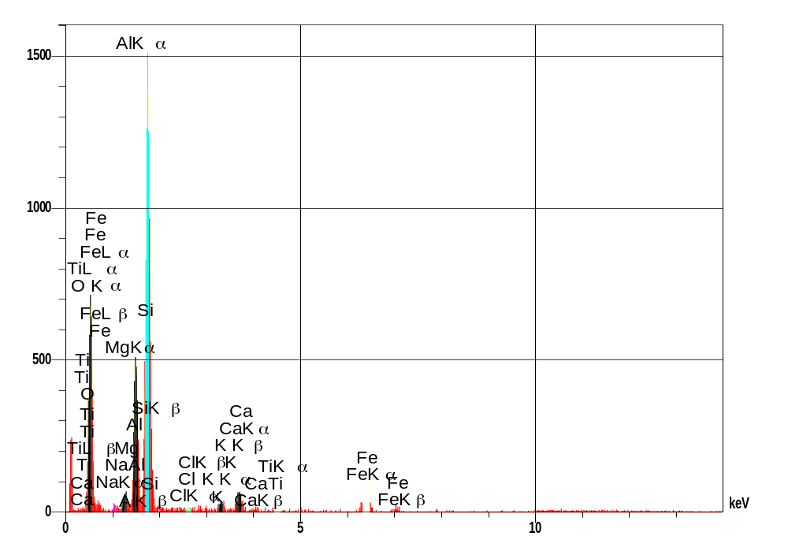
Elt | XRay | Int | Error | W% | A%
Fe | Ka | 6.0 | 0.2239 | 30.16 | 14.75
Si | Ka | 63.3 | 0.7263 | 26.80 | 26.06
O | Ka | 26.3 | 0.4680 | 25.45 | 43.43
Al | Ka | 21.8 | 0.4261 | 9.13 | 9.24
Ca | Ka | 3.7 | 0.1760 | 3.12 | 2.12
K | Ka | 2.0 | 0.1301 | 1.48 | 1.03
Ti | Ka | 1.1 | 0.0950 | 1.46 | 0.83
Mg | Ka | 2.7 | 0.1501 | 1.21 | 1.36
Cl | Ka | 1.1 | 0.0936 | 0.61 | 0.47
Na | Ka | 1.1 | 0.0947 | 0.59 | 0.70
TOTAL |  |  |  | 100 | 100

SEM-EDS Chemistry of YDB layer.

--Add images of TEM CS

SUPPLEMENT--Protocol

--include latest protocol for markers

--ADD HOW TO MAKE CS WITH AND WITHOUT DIAMONDS

--include protocol for ice diamonds WITH OPTIONAL SECTIONS FOR HIGHER RECOVERY

REFERENCES--Supplement

Alley, R.B., C.A. Shuman, D.A. Meese, A.J. Gow, K.C. Taylor, K.M. Cuffey,
J.J. Fitzpatrick, P.M. Grootes, G.A. Zielinski, M. Ram, G. Spinelli, and
B.C. Elder. 1997. Journal of Geophysical Research 102:26367
26381.

B. C. Carlisle, R. B. Braman, Nature, v. 352, p. 708–709 (1991).

Gareth S. Collins, H. Jay Melosh, And Robert A. Marcus. Meteoritics & Planetary Science 40, Nr 6, 817–840 (2005)

Dai, Z. R.; Bradley, J. P.; Joswiak, D. J.; Brownlee, D. E.; Hill, H. G. M.; Genge, M. J. Nature, Volume 418, Issue 6894, pp. 157-159 (2002).

W. Dansgaard, et al., Science 24 December 1982 218: 1273-1277

M.M. Grady, M.R. Lee, J.W. Arden, C.T. Pillinger, Earth Planet. Sci. Lett. 136, 677 (1995).
Hough, R. M., Gilmour, I., and Pillinger, C. T., 1999, in Dressler, B. O., and Sharpton, V. L., eds., Large Meteorite Impacts and Planetary Evolution II: Boulder, Colorado, Geological Society of America Special Paper 339.

R. M. Hough, I. Gilmour, C. T. Pillinger, F. Langenhorst, A. Montanari, Geology, vol. 25, Issue 11, p.1019-1022, (1997).

Grieve RAF, Masaitis VL (1994) The economic potential of terrestrial impact craters. International Geology Review 36: 105-151

Huss, G. R.; Meshik, A. P.; Hohenberg, C. M.; Smith, J. B., 33rd Annual Lunar and Planetary Science Conference, March 11-15, 2002, Houston, Texas, abstract no.1910, 2002

Huss, Gary R.; Lewis, Roy S. Geochimica et Cosmochimica Acta, vol. 59, Issue 1, pp.115-160, 1995

Kennett, D.K., Science, (2009)

C. Köeberl, et al., Geology 25: 967-970, (1997).
F. Langenhorst, G. Shafranovsky, V. L. Masaitis, Meteoritics & Planetary Science, vol. 33, p. A90, abstract 5083, (1998).

Masaitis, V. L.; et al., Large Meteorite Impacts and Planetary Evolution II, Proceedings of the International Conference held 1-3 September, 1997 in Sudbury, Ontario. Edited by B.O. Dressler and V.L. Sharpton. Boulder, CO: The Geological Society of America, 1999., p.317

Nolan, Michael C., et al. American Astronomical Society, DPS meeting #38, #12.06; Bulletin of the American Astronomical Society, Vol. 38, p.504 2006

G. S. Oleinik, A. A. Valter, G. K. Erjomenko, 34th Annual Lunar and Planetary Science Conference, March 17-21, 2003, League City, Texas, abstract no.1561, (2003).

Reimold, Wolf Uwe; Koeberl, Christian; Gibson, Roger L.; Dressler, Burkhard O., Impact Tectonics; with 187 figures. Edited by Christian Koeberl and Herbert Henkel. ISSN: 1612-8338; ISBN: 3-540-24181-7. Published by Springer, Berlin, Germany, 2005, p.479, 2005

R.T. Schmitt, M. Siebenschock, D. Stöffler, Meteoritics & Planetary Science, vol. 34, Supplement, p.A102, 1999.

